

Beauty Hub Booking and POS

Management system

**ASSIGNMENT TOPIC: ANALYSIS**

**Members:** Owethu Lushozi :223046815 Campus: **WESTVILLE CAMPUS**

Nonkanyiso Ngwezi :222017932

Yolanda Mdletshe :222005568

Nqobani Zibane :222002892

Erika Naidoo :223021524

# Client Information:

**Business Name:** Beauty Hub

**Physical Address:** West Street, Durban, KwaZulu-Natal, South Africa

West Walk Arcade

8th floor office number 823

**Contact Details:**

📞 Phone Number: [ +27 61 444 0199 ]

📧 Email Address: [cosmetologistsskincare@gmail.com]

🌍 Website/social media: [<https://www.tiktok.com/@beauty_hub4>]

**Contact Person:**

👤 Name: [Mpume Mphumelelo Mthsali]

📞 Direct Phone Number: [+27 65 555 2265]

📧 Email: [mpumehmpumelelo0@gmail.com]

📌 Position: Admin/Clerk

1.ASSIGNMENT DESCRIPTION

This assignment focuses on analyzing and modeling a **Beauty Hub Booking and Point-of-Sale (POS) Management System** designed for a beauty salon operating in Durban, South Africa. The goal is to capture, understand, and represent the functional needs, data flow, and system interactions that will drive the development of a robust, customer-facing and staff-facing system.

At its core, the system addresses two major operational domains: **appointment booking** and **product sales management**. Both domains are tightly integrated into the daily flow of the business, ensuring customer satisfaction and internal operational efficiency.

# KEY FUNCTIONAL AEAS

**Booking Management**: The system allows customers to:

* **Schedule appointments** by selecting desired services and timeslots.
* **Check availability**.
* **Modify appointments** if needed.
* **Receive confirmations and reminders** through system notifications.

Actors involved include both customers and receptionists. This part of the system ensures smooth scheduling and reduces human error in double-booking or miscommunication.

**Customer Information Management**: Customer records are essential for:

* Storing both new and returning customer profiles.
* Managing CRUD (Create, Read, Update, Delete) operations.
* Supporting customer account creation and archiving old data.

Here, the **front office staff** and **manager** are key actors, with the system cross-checking records to avoid duplication using a unique customer ID. This process requires careful validation and error handling to maintain data integrity.

**Service Management**: This component enables **managers** to:

* Add, update, remove, and organize service offerings.
* Keep the visible list of services up to date for customers.

**Product Sales and Inventory Management**: The **admin** and **manager** collaboratively oversee:

* Adding new products, updating inventory, and removing discontinued items.
* Monitoring stock levels and generating alerts for low inventory.
* Restocking decisions based on system-monitored thresholds.

**Payment Processing**: The payment system supports:

* Multiple payment methods (cash, card).
* Real-time payment verification.
* Generation of detailed receipts.

# MODELS AND DIAGRAMS

The assignment uses:  
**Use Case Diagrams and Descriptions** – to outline the actors, flows, and exception paths.  
**Activity Diagrams** – to visualize process flows   
**Sequence Diagrams and Communication Diagrams** – to show how actors and system components interact over time.  
**State Machine Diagrams** – to track system states, especially inventory levels and appointment confirmations.  
**Class Diagrams** – to define the core system entities and their relationships.

LIST OF USECASES

* **Schedule Appointment**
* Select Service (included in Schedule Appointment)
* Check Availability (included in Select Service)
* Confirm Appointment (included in Check Availability)
* Modify Appointment
* Cancel Appointment
* View Appointment Details
* Receive Appointment Reminder (extended from Confirm Appointment)
* Add New Customer Information
* **Manage Customer Information**
* Display Customer Information
* Update Existing Customer Information
* Create New Customer Account
* Archive Customer Information
* **Manage Services**
* Add new service
* Update service(s) already added
* View service catalogue
* Delete service(s)
* **Manage product sales**
* Monitor Stock
* View Stock Availability
* Restock the product
* Update stock levels
* Display The product stock
* **Process Payments**
* Select Payment Method
* Payment by Card
* Payment by Cash
* Print Receipt

USE CASE DIAGRAMS AND DESCRIPTIONS

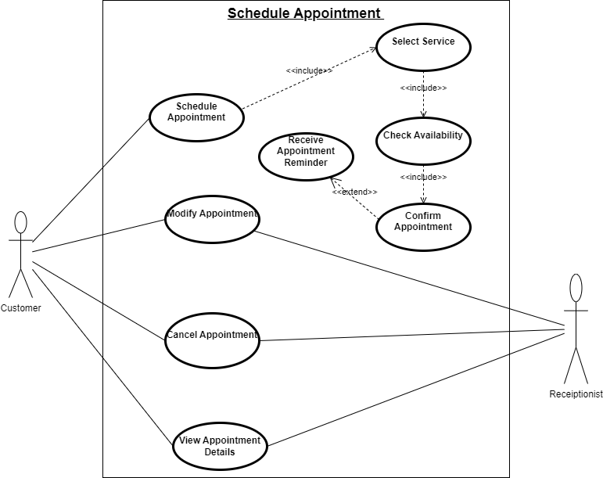**USE CASE: SCHEDULE APPOINTMENT**

|  |  |
| --- | --- |
| USE CASE | DESCRIPTION |
| Schedule Appointment | The customer adds the specifics of what service/s they which to do in their appointment into the system and the system processes the details and makes an appointment. |
| Actors | Customer, Receptionist |
| Related Use Case | - |
| Pre-conditions | Customer wants to book an appointment for a cosmetic procedure that is produced the organisation |
| Post-conditions | 1.Customer receives confirmation of the time and date of their appointment  2.System adds the new appointment into the system database |
| Alternative flow | 1. If the desired cosmetic service is unavailable, the customer must choose a different service  2. If the desired date or time for the service is unavailable, the customer can choose an different date or time. |
| Exception condition | Service Unavailable: the system will tell the customer of the unavailable service and they will have the opportunity to choose a different service or the same service at a different date or time |
| Main flow | 1. Customer selects their desired cosmetic service  2. Customer selects their desired timeslot  3. System confirms payment  4. the system stores the appointment information  5. Customer views their appointment details  6. Customer and receptionist can modify the appointment |

MANAGE CUSTOMER INFORMATION**

|  |  |
| --- | --- |
| USE CASE | DESCRIPTION |
| Manage Customer Information | User/actor the front office staff requests and enters customer information from the customer after their scheduled appointment. The front office staff deals with the CRUD operation in relation to customer information. Manager uses customer information to view customer records and generate customer information reports. |
| Actors | Front office staff |
| Related Use Case | Schedule appointment Use Case |
| Pre-conditions | * A customer database must exist. * If the customer is returning, their record must already be in the database. * If the customer is new, there must be no existing record of them. |
| Post-conditions | Customer information is saved or updated successfully in the database. |
| Alternative flow | * **Returning Customer:**   + Existing customer record is retrieved.   + Staff updates details if needed.   + Changes are saved. * **New Customer:**   New record is created in the system. |
| Exception condition | If a customer tries to register a new account but already has an existing one:   * System identifies the duplicate using unique CustomerID primary key * Staff is notified, and the customer is advised to update the existing account instead. |
| Main flow | 1. Customer completes a scheduled appointment. 2. Front office staff requests customer information. 3. System checks if the customer already exists in the database:    * If yes, the existing record is retrieved.    * If no, a new record is created. 4. Front office staff enters or updates customer details. 5. Staff submits the information.   System validates and saves the customer information. |

**USE CASE: MANAGE SERVICES**

|  |  |
| --- | --- |
| USE CASE | DESCRIPTION |
| Manage Services | This use case permits the manager to add, update, delete and/or organize the services offered by the organization. This is to ensure that what is displayed to the customer it is current and accurate. |
| Actors | Manager |
| Related Use Case | Schedule appointment use case |
| Pre-conditions | * Manager must have permission to use the system – authentication/verification. * The service database must exist. * To update, view, and/or remove the service(s), at least one service must exist in the system. |
| Post-conditions | * New service(s) added must be saved to the database. * Service(s) must be available for viewing and editing. * Updates must be saved to the system.   In the case of a removal of a service or services, they must then not be available in the active services list. |
| Alternative flow |  |
| Exception condition | 2.1 Manager enters a duplicate service name: system must show an error and prompt manager to edit the duplicate service name. |
| Main flow | |  |  | | --- | --- | | **Actor** | **System** | | 1. Manager logs into the system and navigates to the “manage services” section. | 1.1 System displays login page and “manage services” section. | | 1. Manager clicks “add new service” and fills in service details. | * 1. Systems displays a page to enter service details and saves service details.   2. System displays “service added successfully” message. | | 1. Manager selects a service to edit and modifies the necessary details. | * 1. System updates the service in the database.   2. System displays “service updated successfully” message. | | 1. Manager selects a service to delete/remove and confirms the deletion. | * 1. System marks the service as inactive.   2. System displays confirmation message: “service removed successfully.” | | 1. Manager clicks on a service name or “view details.” | * 1. System retrieves and displays service details. | |

**USE CASE: MANAGE PRODUCT SALES**

|  |  |
| --- | --- |
| USE CASE | DESCRIPTION |
| Manage Product Sales | Front Officer has full control over the system and can perform all actions related to managing products, including adding, updating, deleting, and viewing products  * Manager can a view product and monitor the stock (Pending Orders and alerts for low stock) but cannot add/update/delete products.  *The system needs to ensure that product information such as product name, description, price, stock quantity, and other relevant attributes are accurately maintained. |
| Actors | Admin, Manager |
| Related Use Case | - |
| Pre-conditions | The user must be logged in to the system. The users (Admin / Manager) must have appropriate permissions to perform product management tasks.  The system must have an established inventory of cosmetic products before any actions can take place. |
| Post-conditions | Admin: All changes made by the admin are saved in the system.  Manager: The manager views the product details and see the availability of the stock. If the is a low -stock alerts, the manager order the product stock. |
| Alternative flow | If a manager tries to perform an action that is restricted (e.g., adding/updating/deleting a product), the updating or adding a product (e.g., server failure), the system shows a friendly error message and log system displays an access- denied message and prevents the action. If the system encounters an unexpected error while updates the failure for further investigation |
| Exception condition | Unauthorized Access: Users try to access restricted actions (e.g., Managers trying to add/update/delete products).  •Session Timeout: User session expires. Error message is displayed |
| Main flow | Admin: 1. Admin logs into the system.  2. Admin navigates to the "Manage Products" section.  3. Admin selects to add a new product / update an existing product or delete a product  4. The system validates and stores the changes (new product, updated product, or deletion).  5. The product are updated in the system.  Manager: 1. Manager logs into the system.  2. Manager navigates to the "Manage Products" section.  3. Manager views the details of the product and monitor the stock  4. The Manager orders the stock if required  5. The products are updated in the system. |

**USE CASE: PAYMENT**

|  |  |
| --- | --- |
| USE CASE | DESCRIPTION |
| Payment | Receptionist asks customer for his/her preferred payment method. Customer selects payment method and enters details. System processed the payment and produces the customers receipt. |
| Actors | Customer, Receptionist |
| Related Use Case | - |
| Pre-conditions | 1.Customer must purchase one or more items/services.  2.Payment details (e.g. card information) must be provided. |
| Post-conditions | 1.Customer payment must be successfully processed and confirmed.  2.Purchases and money received have been recorded in system.  3.A receipt containing payment details has been generated. |
| Alternative flow | 1.if payment fails, the customer is prompted to select another payment method. |
| Exception condition | Payment failure: if payment fails, system will notify the receptionist and the customer will be prompted to select another payment method. |
| Main flow | Step 1: Customer selects payment method  -Customer selects preferred payment method (card or cash).  Step 2: Payment details  -Customer enters payment details (card and pin/cash).  Step 3: Payment confirmation  -Once payment is authorized, paid amount is checked against total (to check if total was paid)  Step 4: Transaction recording  -System records transaction details (payment amount, payment method)  Step 5: Receipt generation  -A receipt is generated that includes details about the transaction. |

ACTIVITY DIAGRAM

**MANAGE PRODUCT SALES**

**Front Officer**

Enter into the

Manage product

section

Add/Update /remove

the products

Do you want to view

other products?

**System**

Show all the Products

in Beauty hub

Click to the product

Show the details of the

Product

Yes

Is the stock

enough?

Alerts the admin about

the stock

Store the changes

Made

**Manager**

Restock the products

No

**PAYMENT**

Communication Diagrams

SEQUENCE DIAGRAM

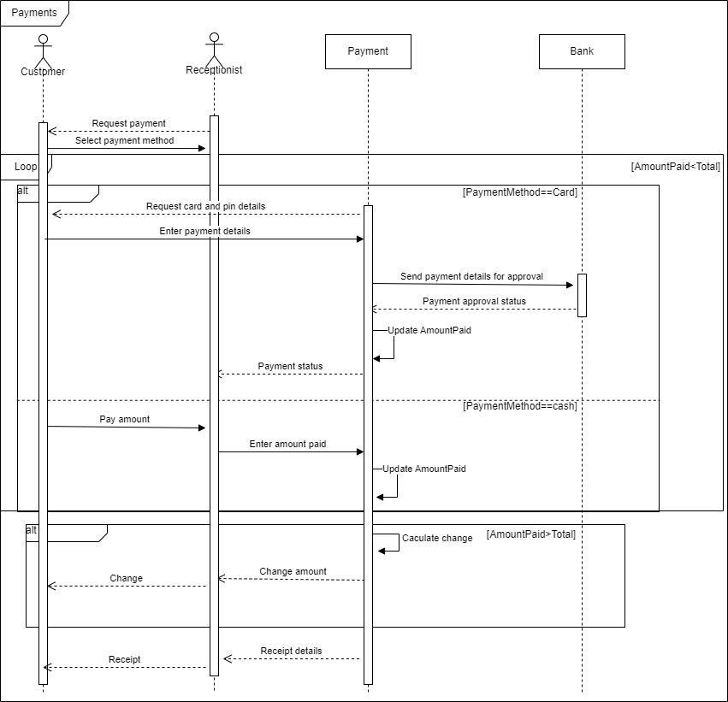

STATEMACHINE DIAGRAMS

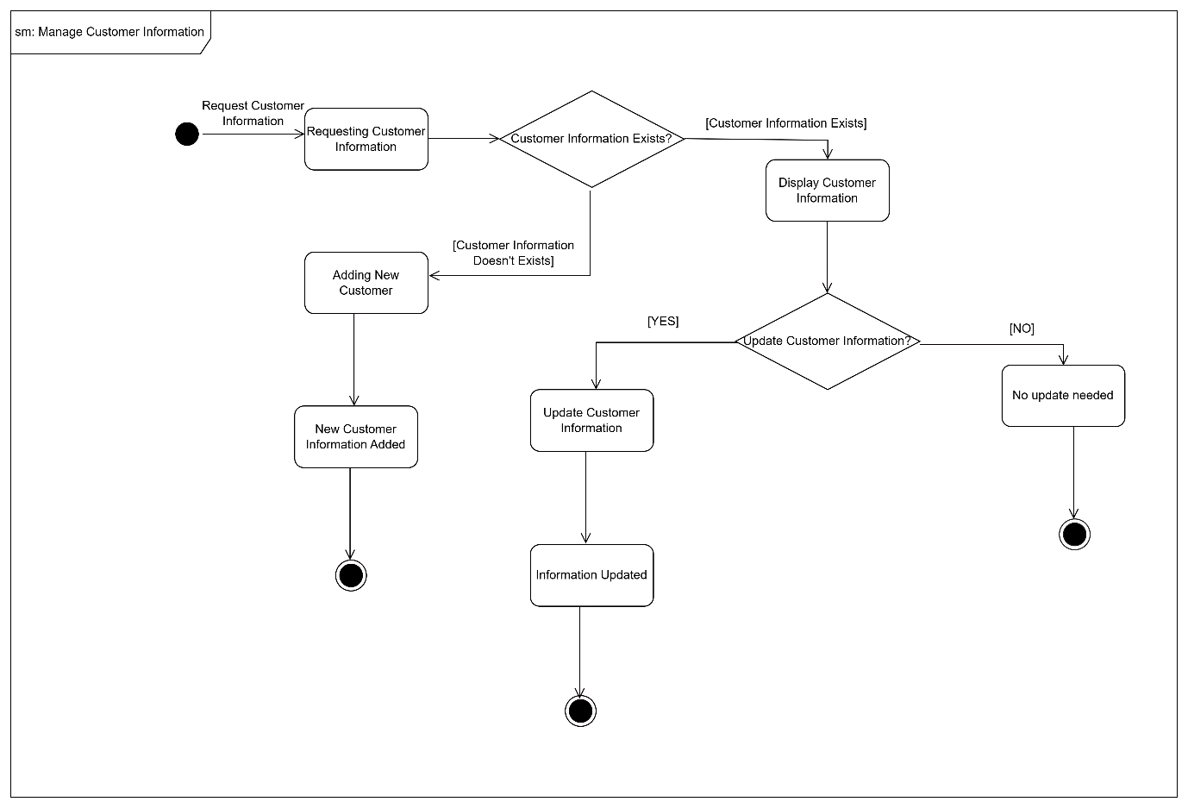

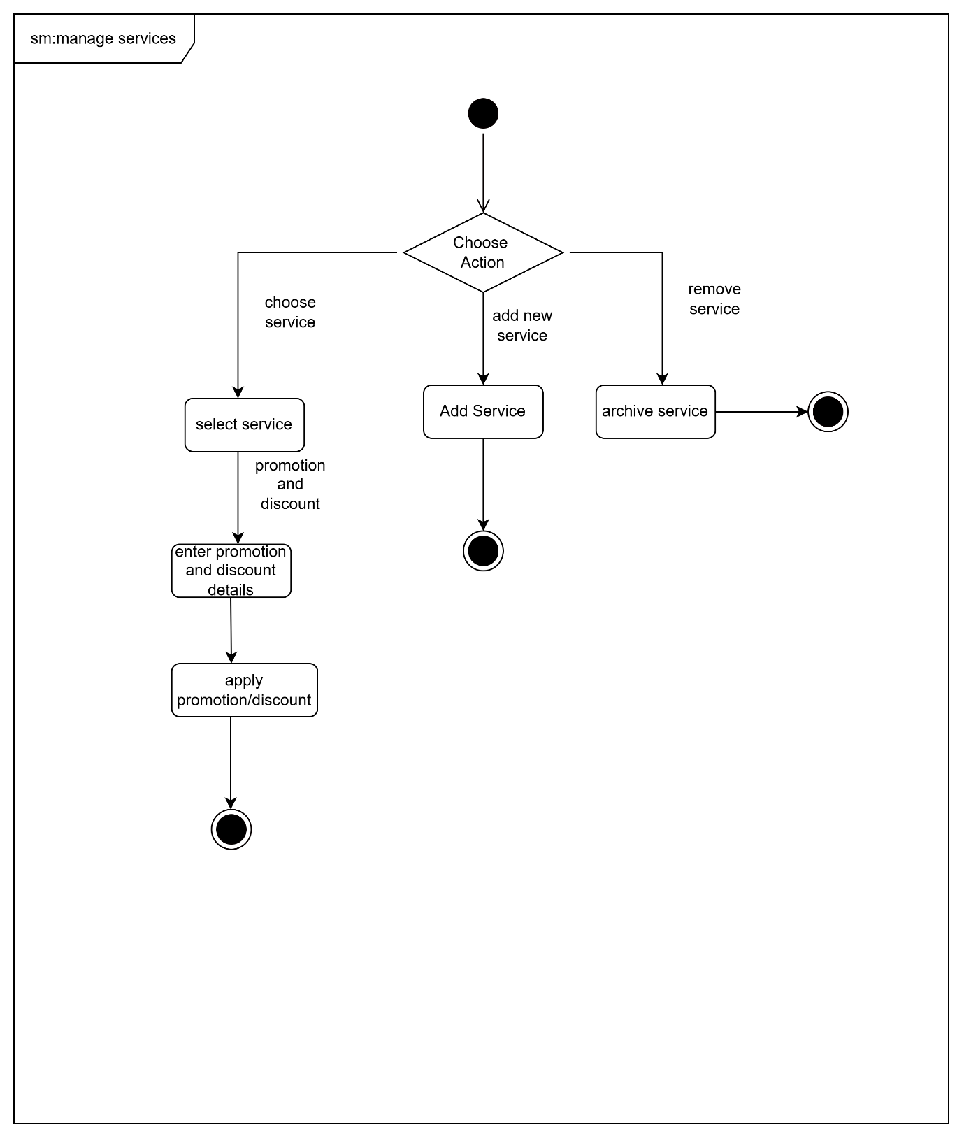

is the Stock enough?

Products restocked

Restock needed

No restock

needed

Showing stock levels

Monitoring the Stock

No

Manage

Product Sales

Yes

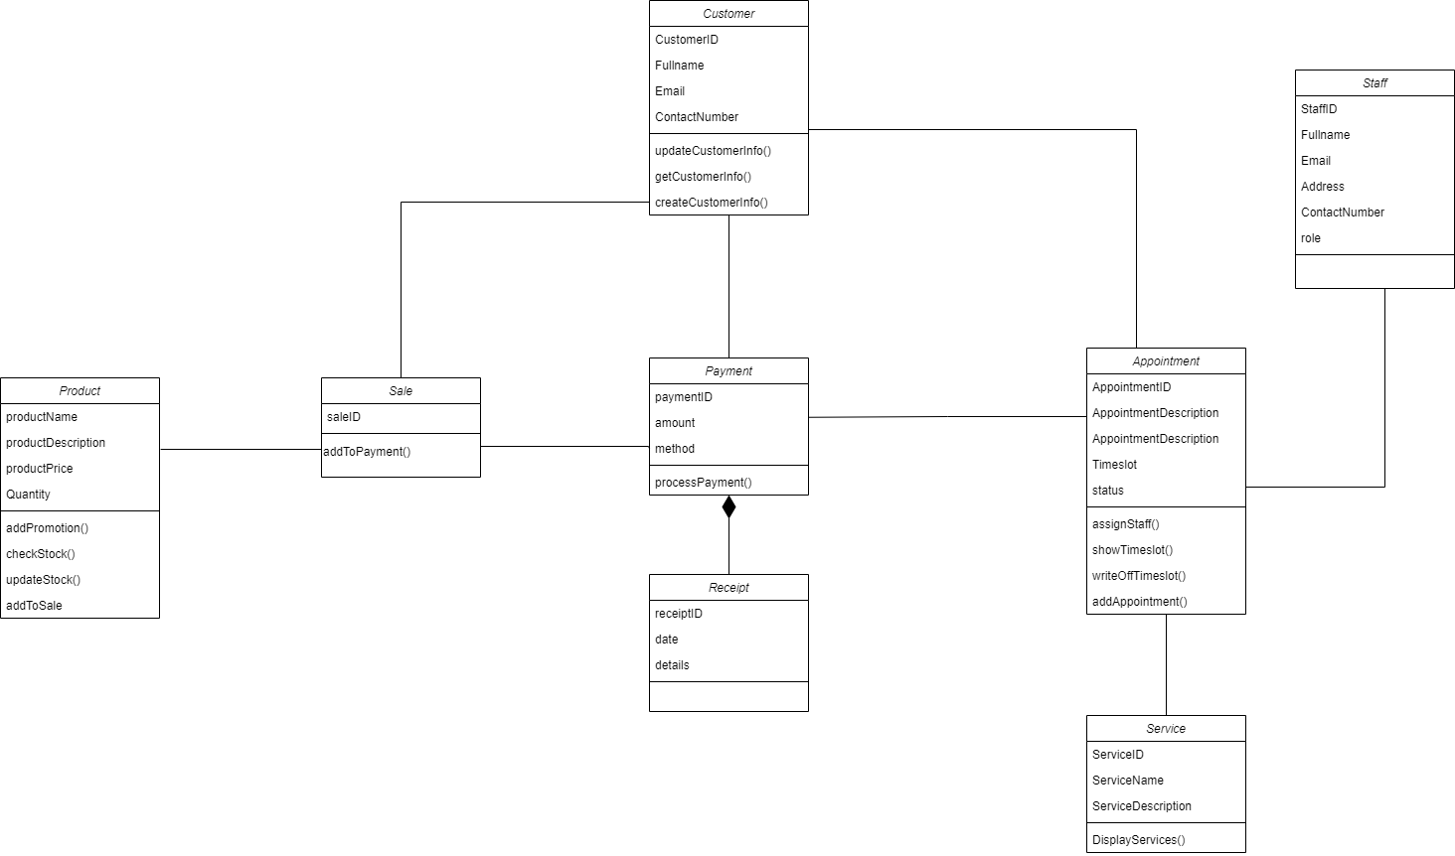ANALYSIS CLASS DIAGRAM

PEER REVIEW

|  |  |  |  |  |
| --- | --- | --- | --- | --- |
| No | Student Numbers | Student Name | % of Contribution | Signature |
| 1 | 223046815 | Owethu Lushozi | 100% |  |
| 2 | 222017932 | Nonkanyiso Ngwezi | 100% |  |
| 3 | 222005568 | Yolanda Mdletshe | 100% |  |
| 4 | 222002892 | Nqobani Zibane | 100% |  |
| 5 | 223021524 | Erika Naidoo | 100% |  |